НТУУ «Київський політехнічний інститут»

Міністерство освіти і науки України

Фізико-технічний інститут

**Програмування**

**Лабораторна робота №4**

**Виконала:**

Алієва Марія

Студентка 1 курсу ФТІ

групи ФЕ-81

**Завдання:**

Частина А

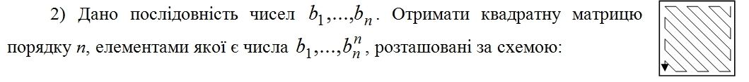

Частина В

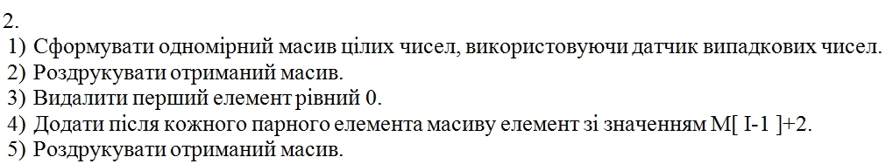

**Код:**

#Частина А

import numpy as np

b = list(map(int, input('Enter characters separated by comma: ').split(',')))

n = len(b)

a = np.zeros((n, n), dtype=int)

i = 0

r = 0

c = n - 1

def check(y):

y += 1

if y == n:

y = 0

return y

if n == 1:

a[0][0] = b[0]

elif n % 2 == 0:

while r != n and c != 0:

if r == 0 and c == n - 1:

a[r][c] = b[i]

i = check(i)

r += 1

if 0 < r < n - 1 and c == n - 1 and r % 2 == 1:

a[r][c] = b[i]

i = check(i)

r -= 1

c -= 1

if 0 < r < n - 1 and c == n - 1 and r % 2 == 0:

a[r][c] = b[i]

i = check(i)

r += 1

if r == 0 and 0 < c < n - 1 and c % 2 == 0:

a[r][c] = b[i]

i = check(i)

c -= 1

if r == 0 and 0 < c < n - 1 and c % 2 == 1:

a[r][c] = b[i]

i = check(i)

c += 1

r += 1

if 0 < r < n - 1 and 0 < c < n - 1 and c % 2 == 1 and r % 2 == 1:

a[r][c] = b[i]

i = check(i)

c -= 1

r -= 1

if 0 < r < n - 1 and 0 < c < n - 1 and r % 2 == 0 and c % 2 == 1:

a[r][c] = b[i]

i = check(i)

r += 1

c += 1

if 0 < r < n - 1 and 0 < c < n - 1 and r % 2 == 1 and c % 2 == 0:

a[r][c] = b[i]

i = check(i)

r += 1

c += 1

if 0 < r < n - 1 and 0 < c < n - 1 and c % 2 == 0 and r % 2 == 0:

a[r][c] = b[i]

i = check(i)

c -= 1

r -= 1

if r == 0 and c == 0:

a[r][c] = b[i]

i = check(i)

r += 1

if r == n - 1 and c == n - 1:

a[r][c] = b[i]

i = check(i)

c -= 1

r -= 1

if r == n - 1 and 0 < c < n - 1 and c % 2 == 1:

a[r][c] = b[i]

i = check(i)

r -= 1

c -= 1

if r == n - 1 and 0 < c < n - 1 and c % 2 == 0:

a[r][c] = b[i]

i = check(i)

c -= 1

if 0 < r < n - 1 and c == 0 and r % 2 == 0:

a[r][c] = b[i]

i = check(i)

r += 1

if 0 < r < n - 1 and c == 0 and r % 2 == 1:

a[r][c] = b[i]

i = check(i)

r += 1

c += 1

if r == n - 1 and c == 0:

a[r][c] = b[i]

r += 1

else:

while r != n and c != 0:

if r == 0 and c == n - 1:

a[r][c] = b[i]

i = check(i)

r += 1

if 0 < r < n - 1 and c == n - 1 and r % 2 == 1:

a[r][c] = b[i]

i = check(i)

r -= 1

c -= 1

if r == 0 and 0 < c < n-1 and c % 2 == 0:

a[r][c] = b[i]

i = check(i)

c += 1

r += 1

if 0 < r < n - 1 and 0 < c < n - 1 and c % 2 == 1 and r % 2 == 1:

a[r][c] = b[i]

i = check(i)

c += 1

r += 1

if r % 2 == 0 < r < n - 1 == c:

a[r][c] = b[i]

i = check(i)

r += 1

if 0 < r < n - 1 and 0 < c < n - 1 and r % 2 == 0 and c % 2 == 1:

a[r][c] = b[i]

i = check(i)

r -= 1

c -= 1

if 0 < r < n - 1 and 0 < c < n - 1 and r % 2 == 1 and c % 2 == 0:

a[r][c] = b[i]

i = check(i)

r -= 1

c -= 1

if r == 0 and 0 < c < n - 1 and c % 2 == 1:

a[r][c] = b[i]

i = check(i)

c -= 1

if r == 0 and c == 0:

a[r][c] = b[i]

i = check(i)

r += 1

c += 1

if 0 < r < n - 1 and 0 < c < n - 1 and c % 2 == 0 and r % 2 == 0:

a[r][c] = b[i]

i = check(i)

c += 1

r += 1

if r == n - 1 and c == n - 1:

a[r][c] = b[i]

i = check(i)

c -= 1

if r == n - 1 and 0 < c < n - 1 and c % 2 == 1:

a[r][c] = b[i]

i = check(i)

r -= 1

c -= 1

if r == n - 1 and 0 < c < n - 1 and c % 2 == 0:

a[r][c] = b[i]

i = check(i)

c -= 1

if r > 0 < n - 1 and c == 0 and r % 2 == 1:

a[r][c] = b[i]

i = check(i)

r += 1

if 0 < r < n - 1 and c == 0 and r % 2 == 0:

a[r][c] = b[i]

i = check(i)

c += 1

r += 1

if r == n - 1 and c == 0:

a[r][c] = b[i]

r += 1

for r in a:

print(r)

#Частина В

import random

arrr = [random.randint(0, 100) for i in range(10)]

print(arrr)

i = 0

while i < 20:

if arrr [i] % 2 == 0:

arrr.insert(i+1, arrr[i-1]+2)

i += 1

i += 1

if len(arrr) == i:

break

print (arrr)

i = 0

while i < 10:

if arrr [i] == 0:

arrr.pop(i)

print (arrr)

break

i += 1

else:

print ('There is no element that is equal to zero')

**Приклад роботи програми**

Частина А

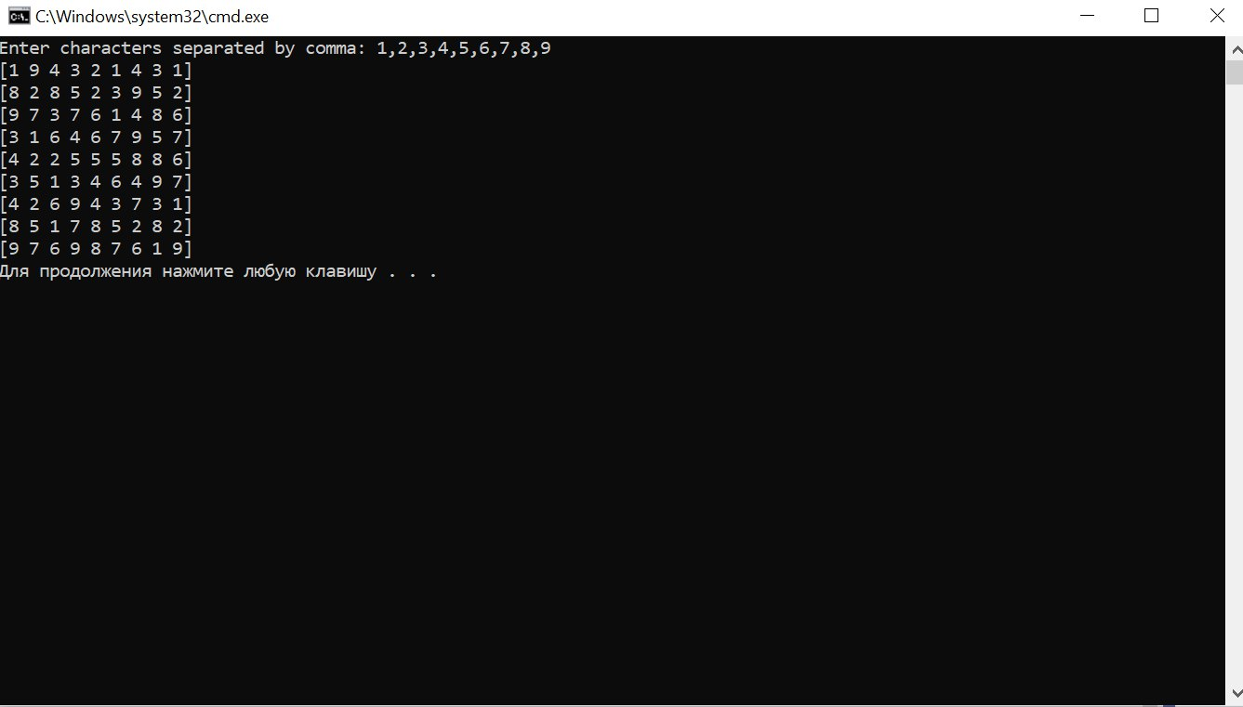

Частина В

